**CSE / EEE / ETE 499A (Section 05)**

**Final Report (CO5)**

**Project Title: NSU RFID Based Smart Print zone.**

**Submitted To**

**Dr. Shazzad Hosain (SZZ)**

**Date: 25/01/2020**



**Group Members**

|  |  |
| --- | --- |
| **ID** | **Name** |
| 1722231042 | Md. Ariful Haque |
| 1721277042 | Fahad Rahman Amik |

Table of Contents:

**Introduction:** **3**

**System Designs:** **4**

Diagram: **4**

**Impacts and Constraints:** **5**

**Methodoligies:** **7**

**Result:** **8**

**Conclusion: 8**

1. Introduction

NSU has a print zone consist of 100 PC (offline) and two (black and white) laser printer, connected with LAN (series). Any NSU student can print from those PCs, after logging in with NSU ID and dedicated password. Every Semester they got free 200 page to print (everyone). Within a semester, if they run out of that page limit, they can renew it by paying 100 taka (100 page) to NSU recognized bank (UCB). There is a software called “Papercut”, which is used (by NSU IT) to maintain those page limits and other authentication stuffs.

The system is good so far. But there are some issues. All students can print together at same time, and there is no queue to be maintained. All document prints together after getting print command. As a result, student often faces hassle on finding their own document form pile of all printed documents, which costs a lot of time. Specially during rush hour, it produces a huge crowd on our Print zone. Also, there are some other issues as well.

Our developed system can handle those issues and add additional time and cost saving features to it

1. System Design

On our developed system, user will print document as it done before. Additionally, there will be RFID card reader attached to our printers. Here, documents will not be printed directly after getting print command from PC. Our system will hold it. After giving print command, user will sign out their account and go beside printer, punch his/her NSU id card, after that, printer will print only that users document, immediately. So, there will be no pile of printed documents.

Theoretically user will bound to maintain a queue on their own. First come (to printer) first serve. Our printing system will be connected to our RDS as well. User will upload their documents to print account, through RDS. Whenever user punch their card from printer, there document will be printed immediately. Means our printing system will be available online. They can upload document from home, and print it from University. They can check there printing status (page left, total printed page and many more) on RDS. They can use their phone, so the printing job will be more flexible and fun.

**Our system will be as following -** indicates offline part and indicate online part

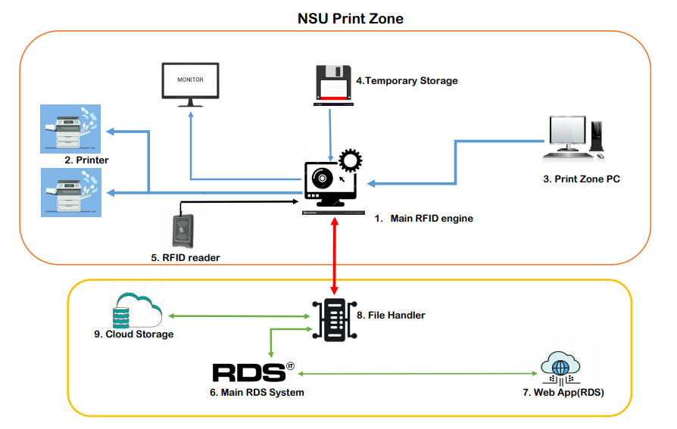

1. Impacts and Constraints

Our main target is to reuse all of the available resources on NSU IT. No additional hardware will be needed at all. Our system software will handle everything. Though software making cost is zero, hardware has some cost. Point to be noted, all hardwires we need, is already present on NSU IT. So, no need to buy anything. But a rough estimation is given bellow.

|  |  |
| --- | --- |
| **Product** | **Price (per unit)** |
| Server PC | 150,000 TK |
| Server Cost | Depends on Requirement |
| RFID Reader (Paxton) | 13000Tk |
| RFID Card | 100Tk |
| Web App Server | Depends on requirement |
| Printer | 50,000TK |
| RFID Reader Controller | 3000TK |

*Additionally, there are no tax incentives.*

# **Environmental Impact of the product:**

* Our System will reduce environmental pollution as we are going to reuse the existing printer and they are not going to be wasted and not going to cause any environmental pollution.
* Our system will reduce page wastage which will bring a change in consumption and also reduce

# **Social Impact of the product:**

* The developed product will bring a magnificent impact on our student’s day to day life. They will not to wait for long time in front of printer to get their documents to be printed. After the implementation of our products number of printers will also be increased. Admin can easily monitor students. Students will never miss any single document after printing job is done because at a time a single user’s document will be printed. So, no chance of overlapping.
* It addresses the need of Admin of NSU it and Students of NSU.
* There are no social and environmental constraints at all.

# **Legal considerations and constraints:**

* Regularity issues: Web app cyber security
* Existing technology limitations: No such limitations
* Existing standards that impact the system design requirements: As the print zone pc is connected with Ethernet LAN port so we have to maintain IEEE Fast Ethernet/ 100Base-T 802.3u standard.
* Standardized security mechanism: As we are planning to deploy our web app in AWS so there is some security protocols such as TCP and SSH protocols.
* Standardized software development: We are using Laravel PHP framework and C# for client app + RFID engine (server software).
* Standardized software engineering practices: We are following software development guidelines and rules. We maintained all guidelines of SE like DRY, KISS and SOLID
* Open source standards, software, and operating systems: We will use Linux open source operating system for our web app server and windows for RFID engine. We are going to use Apache Server which will be installed in both windows and Linux. And OPEN license software called “BulllZip”.

1. Methodologies

These components will work together to make our system function-

**a. Main RFID engine:** This is the core system (an ordinary PC with 16GB or more RAM and more than 8 core), which will be responsible for handling all print request and binding RFID punches to desired documents. Basically, it will be available offline, but it will maintain communication with file handler (which will be online). We don’t need a dedicated server PC here, because that will be over whelming for our need. There will be a data storage (HHD/SSD) inside Main RFID engine PC. Requested documents (online/offline) will be stored here temporarily, as user punch their card, document will be printed immediately. As actual document will be on Print Zone pc(offline) or on RDS (online). During punch if the document is not available on this storage, then it must be downloaded from source (online/offline), which will generate time overhead. So, this storing is required to make printing job faster. Max 2TB storage will be sufficient. There is a good chance of generating some storage leak, our system design will handle it.

**b. Print Zone PC:** Our ordinary PCs, located on print zone, usually we do print from those. (around 100 in count)

**c. RFID reader:** Usual RFID reader, as we see beside every NSU classroom door. There will be one reader for each printer, attached to it.

**d. Main RDS system:** Our as usual RDS system, to make printing system available online, our designed system will be connected to it. Just some API call, to make it accessible from RDS portal.

**e. Web app (RDS):** Our as usual RDS web app (user interface).

**f. File Handler:** RDS system will just redirect any print related request to it. Technically it is the main online part of our proposed system. It will handle online validation and uploading job. Also, will track printing status to make users print details available online. Also, it will maintain communication with Main RFID Engine to track live updates. There will be another temporary storage, it will be an online storage rather than offline. It will store all online uploads temporarily. RFID engine [1] will request for any user’s document to File Handler, and Handler will transfer that file/files from this Cloud Storage.

1. Result

This system will reduce time and cost, for both users and organization owners. Printing experience will be flexible and fun for users. They we be able to print from home and abroad. On the other hand, there will be no hassle on finding their desire printed document. There will no longer be any pile of documents. Also, user will be able to stop printing if needed. Page waste will be minimal.

For organization, admins can monitor their user more closely and rough time. Super admin will have maximum privileges among all other admins. Super admin can monitor other admins activity, along with users. System will have blank page checker. So, it can prevent user from printing blank page. Usually that check takes place manually.

1. Conclusion

This semester we developed 55% of our project. On 499B, we will conclude. Core system will be developed then. We did finalize all our remaining methods by various number of trials. We do come up to an optimum solution, for almost all remaining functionality. Now what remains is only development. We can save couple of million taka, to whoever purchase this system.